SB STOCKS
Full-Stack Stock Market Paper Trading Simulation Platform
MERN Stack Project Documentation
Field | Details
Project Title | SB Stocks — Stock Trading Simulation Platform
Team ID | SWTID-2026-3267
Team Lead | S L Kesavaananda
Team Member | Srikakulam Meghana
Team Member | Sanjeeva Manasa Settipalle
Mentor | No mentor assigned yet
Technology Stack | MongoDB, Express.js, React.js, Node.js

1. Introduction

1.1 Project Title
SB Stocks — A Full-Stack Stock Market Trading Simulation Platform (Paper Trading).

1.2 Team Members and Roles
Name | Role
S L Kesavaananda | Team Lead
Srikakulam Meghana | Member
Sanjeeva Manasa Settipalle | Member

2. Project Overview

2.1 Purpose
SB Stocks is a user-friendly web application built for stock market enthusiasts who want to practice and improve their trading skills without financial risk. The platform provides paper trading powered by simulated real-time US stock market data, historical trends, and a wide range of stock listings. Each new user starts with $100,000 in virtual cash to buy and sell across 100 US stocks, track portfolio performance, and analyze strategies in a realistic environment — making it useful for both beginners learning the basics and experienced traders testing new strategies.

2.2 Key Features
- Secure registration and login with role-based access (User / Admin).
- Virtual trading balance of $100,000 per user with real-time balance updates.
- Stock Explorer covering 100 US stocks with search, sector filters, sorting, and pagination.
- Live simulated market ticker with continuously fluctuating prices.
- Buy/Sell order execution with instant cost calculation and balance validation.
- Portfolio dashboard with holdings, average price, current value, and P&L tracking.
- Transaction ledger with BUY/SELL history, filters, and CSV export.
- Watchlist management for tracking favorite stocks.
- Interactive price charts using Recharts for historical trends.
- Portfolio report export to PDF and CSV.
- Admin console for platform-wide analytics and user/stock management.
- Responsive dark/light-mode UI built with React and Tailwind CSS.

3. Architecture

3.1 Frontend Architecture (React)
The client is built with React 18 and Vite for fast builds, using Redux Toolkit for global state management (auth, portfolio, stocks). Tailwind CSS drives the styling system with a dark-mode-first, Bloomberg/Robinhood-inspired design. Recharts renders price and allocation charts, Framer Motion powers UI transitions, React Toastify handles notifications, and jsPDF generates exportable portfolio reports. Axios communicates with the backend REST API and React Router handles client-side routing between pages such as Dashboard, Stock Explorer, Portfolio, Watchlist, Transactions and Admin Dashboard.

3.2 Backend Architecture (Node.js / Express.js)
The server is built on Node.js with Express.js, organized into a layered structure: routes define REST endpoints, controllers handle request/response logic, services encapsulate business logic (authentication, stock pricing, portfolio calculations, admin operations), and a market simulator periodically updates simulated stock prices. Middleware handles JWT authentication, role-based authorization, centralized error handling, request validation, and rate limiting. Mongoose is used as the ODM layer to MongoDB.

3.3 Database Design (MongoDB)
MongoDB stores all persistent data across five core collections, linked through user and stock references:
Collection | Key Fields
Users | name, email, password (hashed), role (USER/ADMIN), avatar, balance
Stocks | symbol, companyName, sector, currentPrice, previousClose, high, low, volume, chartHistory
Portfolios | userId, stockId, quantity, averagePrice, currentPrice, profitLoss
Transactions | userId, stockId, transactionType (BUY/SELL), quantity, price, totalAmount
Watchlists | userId, stockId

4. Setup Instructions

4.1 Prerequisites
- Node.js v16 or later, and npm
- MongoDB (local instance or MongoDB Atlas connection string)
- Git for version control
- Postman (recommended) for API testing

4.2 Installation
# 1. Clone the repository
git clone <repository-url> sb-stocks && cd sb-stocks
# 2. Install backend dependencies
cd server && npm install
# 3. Configure environment variables (server/.env)
MONGO_URI=<mongodb-connection-string>
JWT_SECRET=<your-secret-key>
PORT=5173
# 4. Install frontend dependencies
cd ../client && npm install
Backend dependencies: express, mongoose, bcryptjs, jsonwebtoken, cors, dotenv. Frontend dependencies: axios, react-router-dom, redux (Redux Toolkit), react-toastify, chart.js/recharts.

5. Folder Structure

5.1 Client (React Frontend)
client/src/
├── pages/ Home, Login, Register, Dashboard, Stocks,
│ StockDetails, Portfolio, Transactions,
│ Watchlist, Profile, AdminDashboard
├── components/ Navbar, Sidebar, TickerBar, TradeModal, Charts
├── redux/ store, authSlice, portfolioSlice, stockSlice
├── services/ axios API client wrappers
└── App.jsx Route definitions

5.2 Server (Node.js Backend)
server/
├── config/ db.js, logger.js
├── models/ User, Stock, Portfolio, Transaction, Watchlist, Analytics
├── middleware/ authMiddleware, errorHandler, rateLimiter, validator
├── services/ authService, stockService, portfolioService,
│ adminService, marketSimulator
├── controllers/ route handler logic per module
├── routes/ /api/auth, /api/stocks, /api/portfolio,
│ /api/transactions, /api/watchlist, /api/admin
└── seed/ stocksData.js, seed.js

6. Running the Application

6.1 Seed the Database
cd server && npm run seed
Populates 100 US stocks, an Admin account (admin@sbstocks.com / Admin@12345) and a Demo Trader account (trader@sbstocks.com / Trader@12345) with a $100,000 starting balance.

6.2 Start the Backend
cd server && npm run dev

6.3 Start the Frontend
cd client && npm start
The frontend runs on the Vite dev server and communicates with the Express API for authentication, stock data, trading and portfolio operations.

7. API Documentation
Endpoint | Method | Description
/api/auth/register | POST | Register a new user account
/api/auth/login | POST | Authenticate user and issue JWT
/api/stocks | GET | List/search/filter all stocks
/api/stocks/:id | GET | Get stock details and price history
/api/portfolio | GET | Get logged-in user's holdings
/api/portfolio/buy | POST | Execute a buy order
/api/portfolio/sell | POST | Execute a sell order
/api/transactions | GET | Get user's transaction history
/api/watchlist | GET/POST/DELETE | View, add, or remove watchlist stocks
/api/admin/users | GET | Admin: list registered users
/api/admin/stocks | POST/PUT/DELETE | Admin: manage stock listings
All protected endpoints require a Bearer JWT in the Authorization header. Request bodies are JSON; responses follow a consistent { success, data, message } shape with standardized error codes handled by the centralized error middleware.

8. Authentication
Authentication is handled using JSON Web Tokens (JWT). On login or registration, the server verifies credentials (passwords hashed and compared using bcrypt) and issues a signed JWT containing the user's ID and role. This token is stored client-side and sent with each request via the Authorization header.
- authMiddleware.authenticateUser verifies the JWT and attaches the user to the request.
- authMiddleware.authorizeAdmin restricts admin-only routes (e.g. stock/user management) to users with the ADMIN role.
- Passwords are never stored in plain text — bcrypt hashing is applied before persistence.
- Two roles are supported: USER (trading, portfolio, watchlist) and ADMIN (platform analytics, user and stock management).

9. User Interface
The interface uses a dark-mode-first design with a live scrolling market ticker, emerald-green for gains and crimson for losses, and a persistent sidebar for navigation across Dashboard, Stock Explorer, Portfolio, Watchlist, Transactions and Profile.

9.1 Dashboard
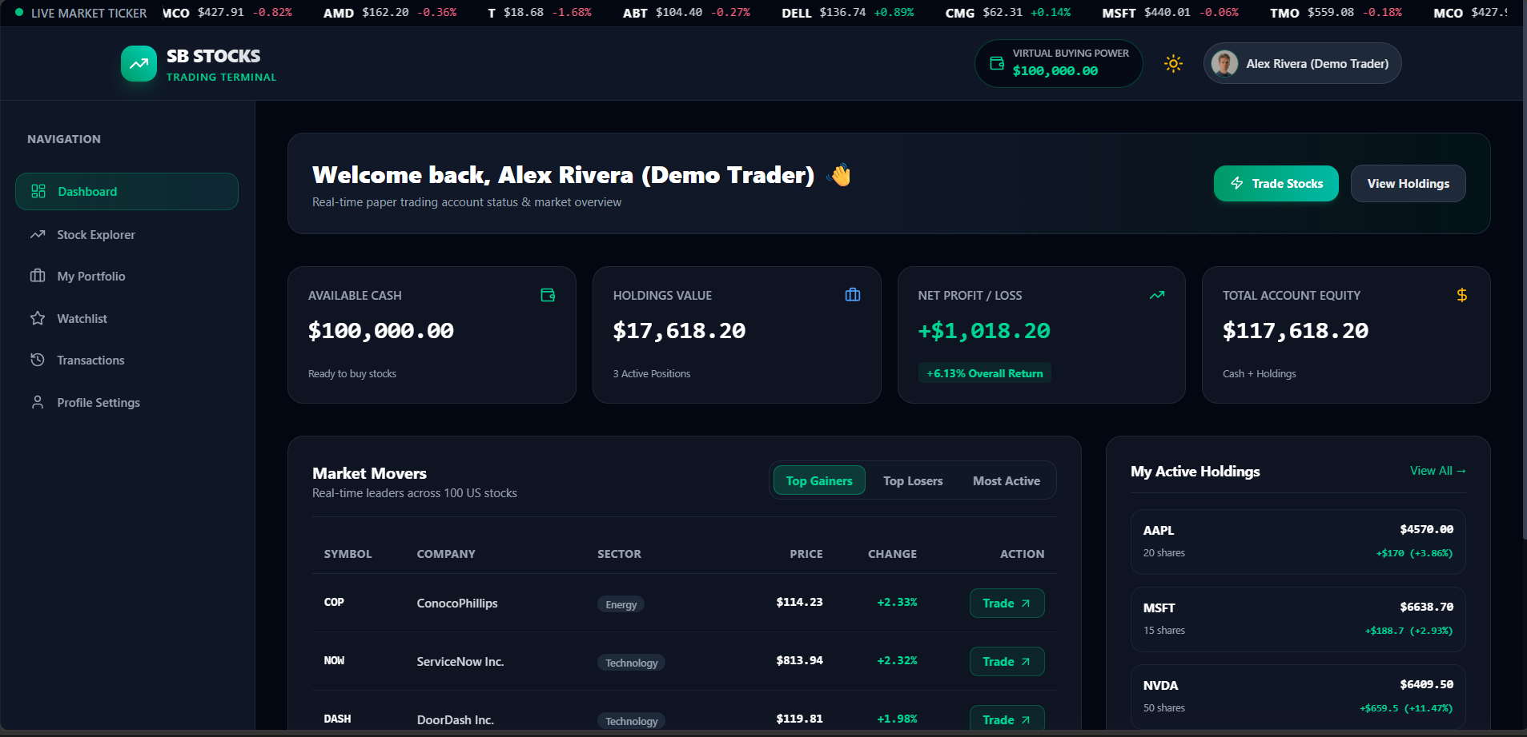
Figure 1: Trader Dashboard — balance overview, market movers, and active holdings.

9.2 Stock Explorer
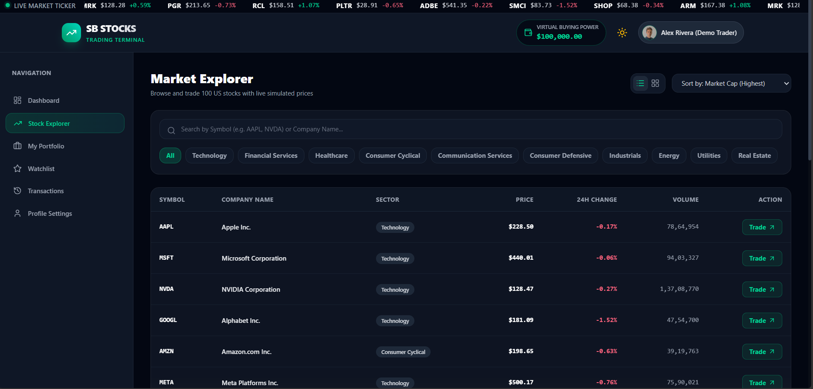
Figure 2: Stock Explorer — search, sector filters, and live price listings for 100 US stocks.

10. Testing
Testing combines automated API checks with manual end-to-end verification across both roles.
- API endpoints (auth, stocks, portfolio, transactions, watchlist, admin) tested using Postman collections covering success and validation-error cases.
- Manual verification of registration/login flow, including demo quick-login buttons for Trader and Admin.
- Trade execution testing: buying/selling shares, verifying balance deduction, portfolio P&L, and transaction ledger updates.
- Stock search, sector filtering, sorting and pagination validated across all 100 seeded stocks.
- Watchlist add/remove and portfolio PDF/CSV export verified for correctness.
- Responsiveness and navigation tested across desktop and mobile breakpoints.

11. Screenshots / Demo

11.1 Portfolio
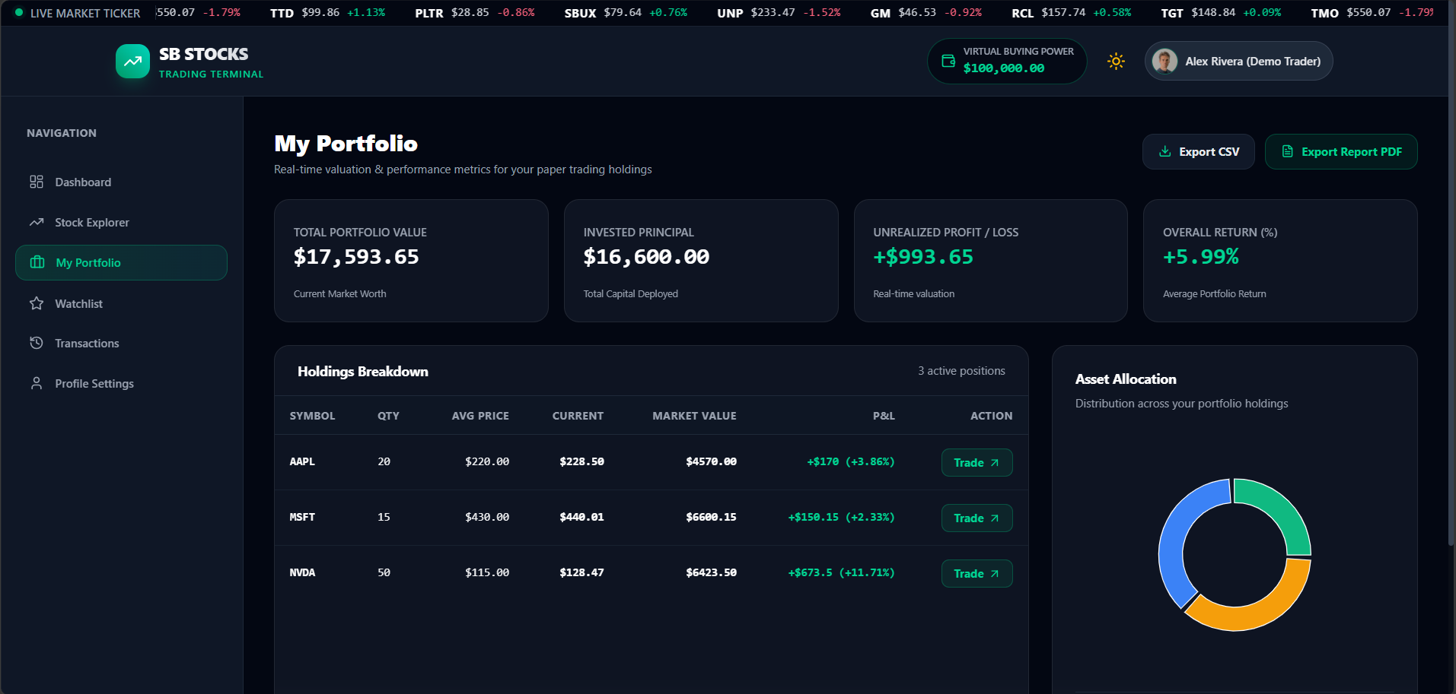
Figure 3: Portfolio page — holdings breakdown, P&L, and asset allocation chart.

11.2 Watchlist
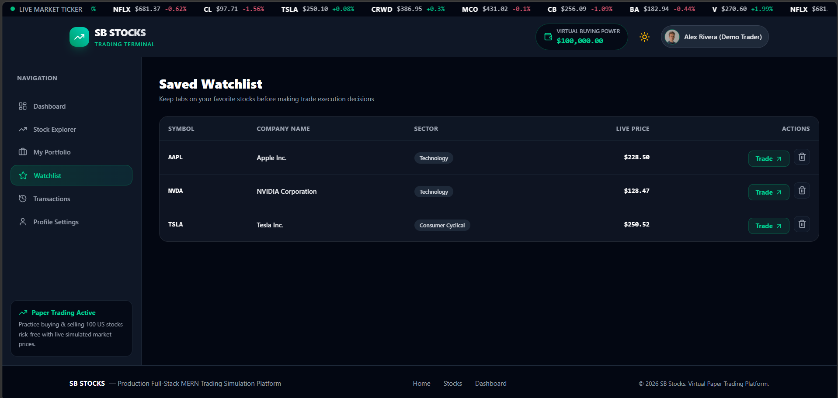
Figure 4: Watchlist — saved favorite stocks with quick trade access.

11.3 Admin Console
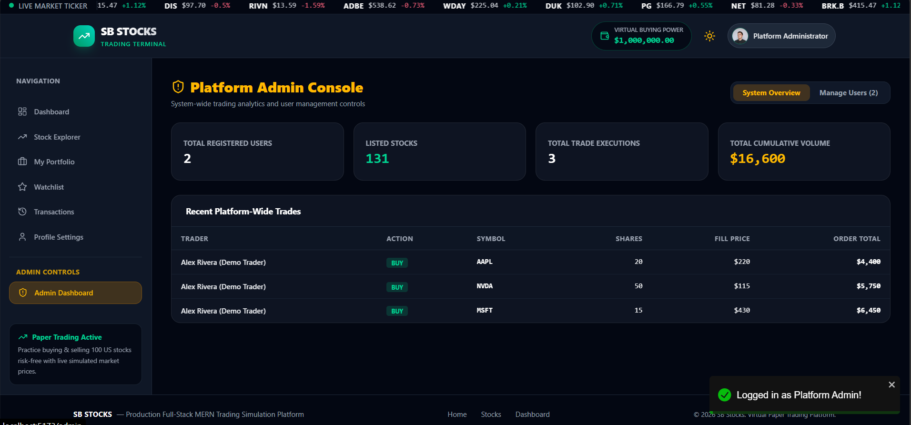
Figure 5: Admin Console — platform-wide analytics, users, and trade oversight.

12. Known Issues
- Stock prices are simulated (not connected to a live market data feed), so movements do not reflect real market conditions.
- Chart history is limited to a fixed 30-day simulated window.
- No real-money integration — the platform is strictly for practice/education.
- Concurrent buy/sell requests on the same holding may require additional locking to fully prevent race conditions.

13. Future Enhancements
- Integrate a real-time market data API for live (non-simulated) US stock prices.
- Add price alerts and notifications for watchlist stocks.
- Support limit orders, stop-loss orders, and order scheduling.
- Add leaderboards and social features to compare performance with other traders.
- Expand analytics with risk metrics (Sharpe ratio, volatility, sector exposure).
- Mobile app version using React Native.

